**LUCRAREA NR. 2 Ungureanu Radu Costin**

**DIODA SEMICONDUCTOARE Grupa: 323CC**

Schema electrica:

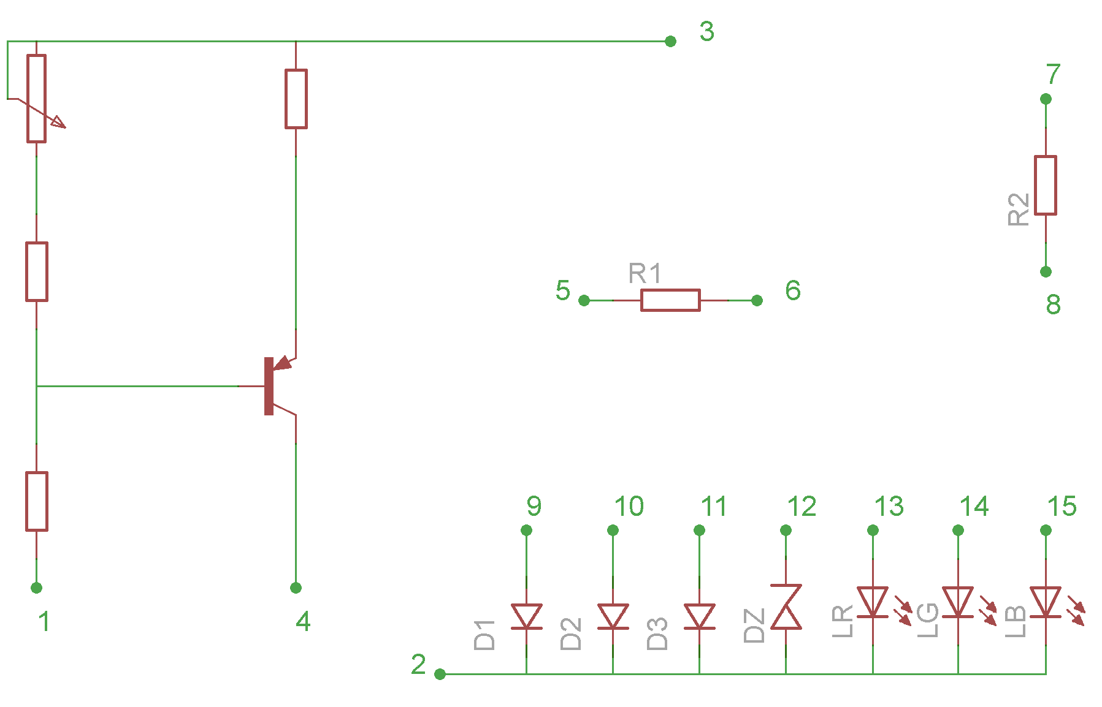

D1 - 1N4148 (dioda din siliciu, de viteza) (borna 9 este anodul);

D2 - EFR 135 (dioda redresoare din germaniu) (borna 10 reprezinta anodul);

D3 - 1N5819 (dioda Schottky) (borna 11 reprezinta anodul);

DZ - BZX 85 C5V6 (diodă stabilizatoare de tensiune) (anodul este borna 2).

LR - LED roşu (anodul la borna 13);

LG - LED verde (anodul la borna 14);

LB - LED albastru (anodul la borna 15).

Conectarea bornelor pentru sursa de curent: +18V la borna 3, borna 1 la masă.

Pentru realizarea montajului, sursa de curent (borna 4) se conecteaza la + -ul miliampermetrului, borna - a miliampermetrului la + -ul diodei (bornele 9, 10, 11, 13, 14, 15). Borna 2 se cupleaza la masa (borna 1). Voltmetrul se conecteaza intre borna + a diodei si masa (borna 1).

1. Caracteristici directe:

|  |  |  |  |  |  |  |  |
| --- | --- | --- | --- | --- | --- | --- | --- |
| ID(mA)  I(mA) | USi(V) | UGe(V) | USchottky(V) | UZener(V) | ULR(V) | ULG(V) | ULB(V) |
| 0.1 | 0.48 | 0.03 | 0.17 | 0.37 | 1.56 | 1.74 | 2.96 |
| 0.2 | 0.52 | 0.05 | 0.19 | 0.41 | 1.59 | 1.78 | 3.12 |
| 0.5 | 0.57 | 0.07 | 0.23 | 0.47 | 1.63 | 1.83 | 3.29 |
| 1 | 0.62 | 0.10 | 0.25 | 0.51 | 1.67 | 1.87 | 3.40 |
| 2 | 0.69 | 0.18 | 0.28 | 0.56 | 1.70 | 1.92 | 3.51 |
| 5 | 0.78 | 0.26 | 0.29 | 0.64 | 1.76 | 2.05 | 3.74 |
| 10 | 0.85 | 0.33 | 0.32 | 0.65 | 1.83 | 2.07 | 3.87 |
| 20 | 0.94 | 0.36 | 0.36 | 0.72 | 1.93 | 2.22 | 4.16 |

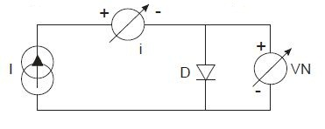

1. La curentul I9 = 5mA, se incalzeste cu mana prima diode 1(1N4148) si se constata o scadere a tensiunii directe pe dioda: 0.781 V -> 0.773 V
2. Grafice:

|  |  |  |  |  |  |  |  |
| --- | --- | --- | --- | --- | --- | --- | --- |
| lg(ID) | USi(V) | UGe(V) | USchottky(V) | UZener(V) | ULR(V) | ULG(V) | ULB(V) |
| -1 | 0.48 | 0.03 | 0.17 | 0.37 | 1.56 | 1.74 | 2.96 |
| -0.7 | 0.52 | 0.05 | 0.19 | 0.41 | 1.59 | 1.78 | 3.12 |
| -0.3 | 0.57 | 0.07 | 0.23 | 0.47 | 1.63 | 1.83 | 3.29 |
| 0 | 0.62 | 0.10 | 0.25 | 0.51 | 1.67 | 1.87 | 3.40 |
| 0.3 | 0.69 | 0.18 | 0.28 | 0.56 | 1.70 | 1.92 | 3.51 |
| 0.7 | 0.78 | 0.26 | 0.29 | 0.64 | 1.76 | 2.05 | 3.74 |
| 1 | 0.85 | 0.33 | 0.32 | 0.65 | 1.83 | 2.07 | 3.87 |
| 1.3 | 0.94 | 0.36 | 0.36 | 0.72 | 1.93 | 2.22 | 4.16 |

|  |  |  |  |  |  |  |  |
| --- | --- | --- | --- | --- | --- | --- | --- |
|  | Siliciu | Germaniu | Schottky | Zener | LED R | LED G | LED B |
| lg(I0) | -3.19 | -0.87 | -3.12 | -3.39 | -10.64 | -9.16 | -6.91 |
| I0(mA) | 6.45*10-4 | 0.13 | 7.58*10-4 | 4.07*10-4 | 2.29*10-11 | 6.19*10-10 | 1.23*10-7 |
| γ | 3.40 | 2.69 | 1.33 | 2.54 | 2.64 | 3.47 | 8.31 |

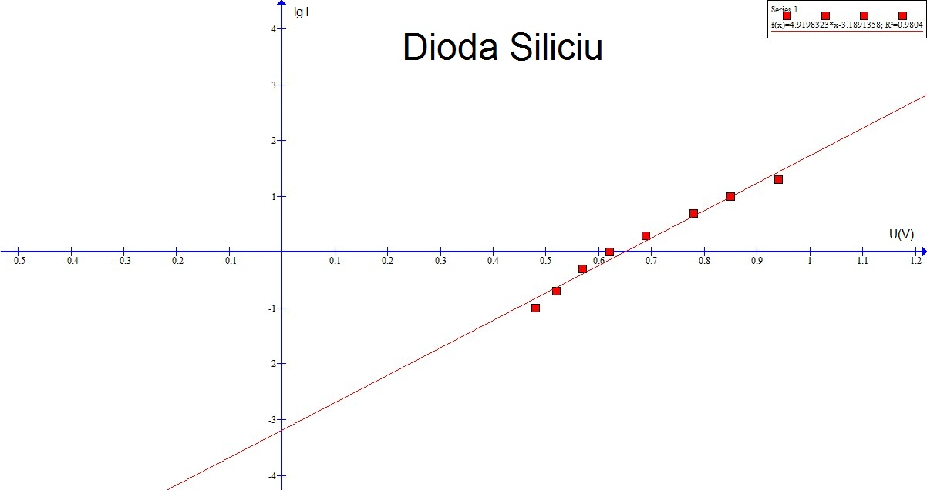

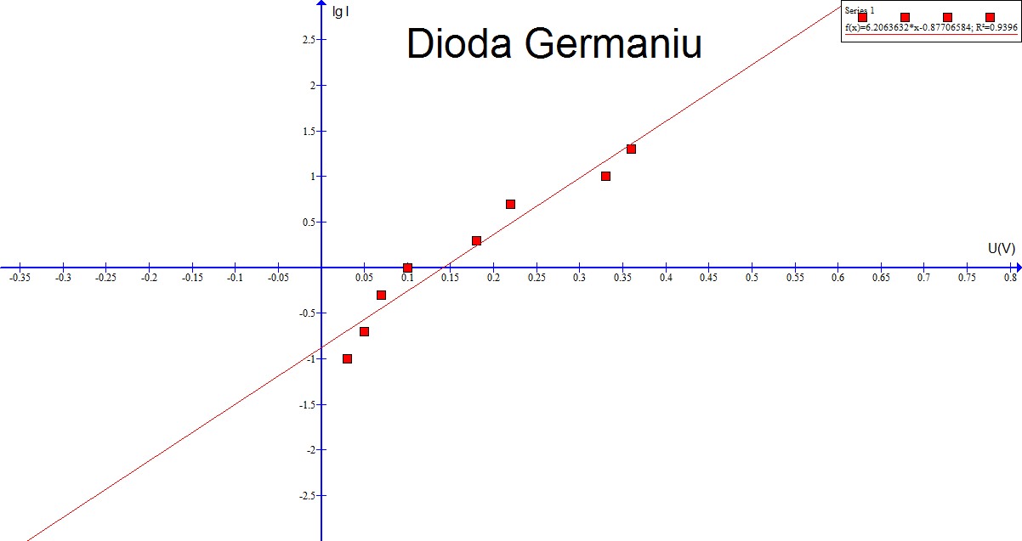

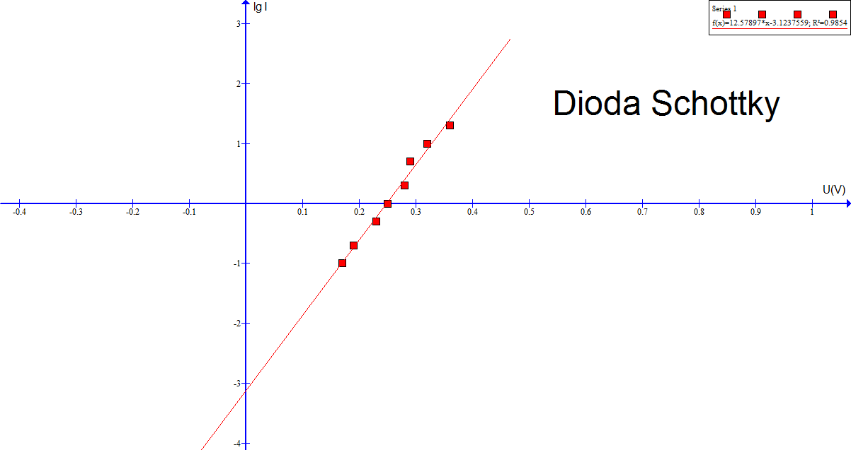

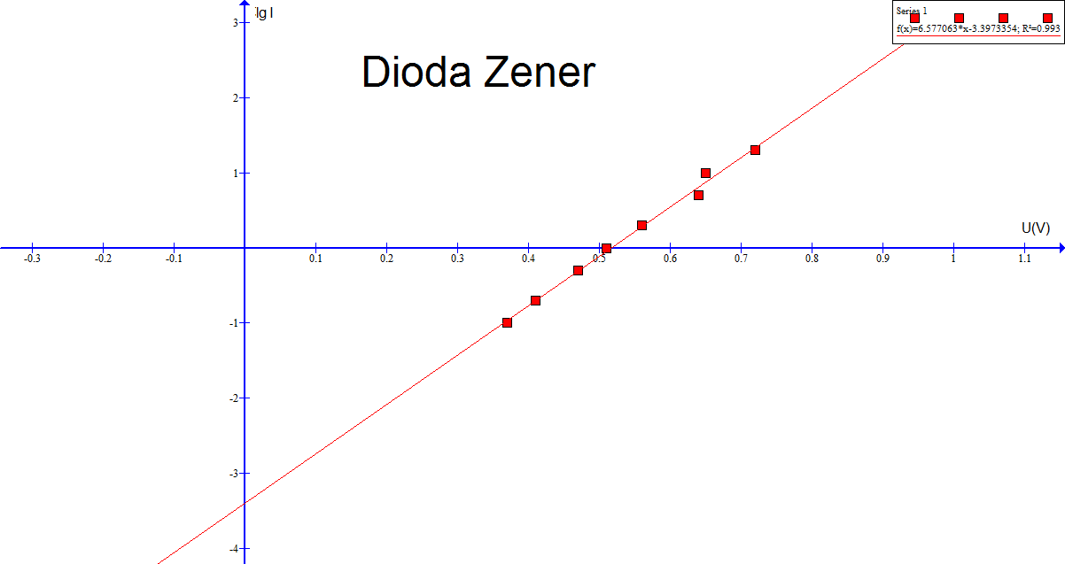

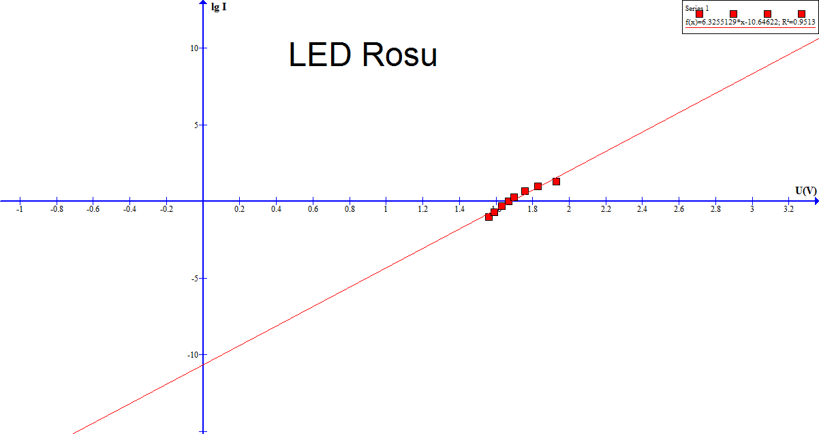

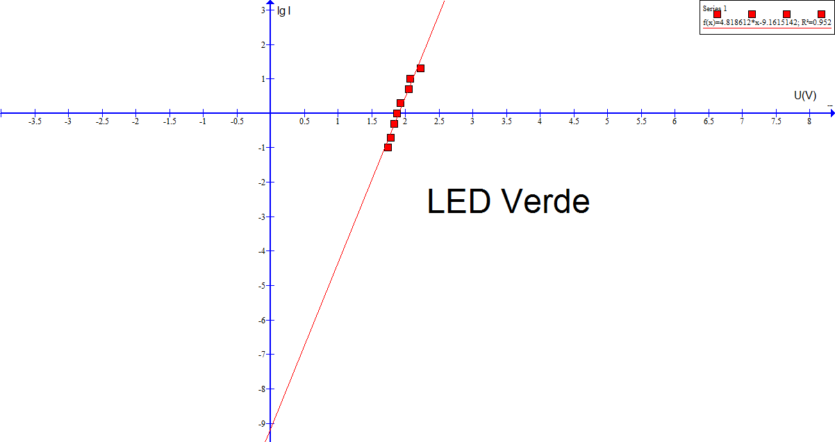

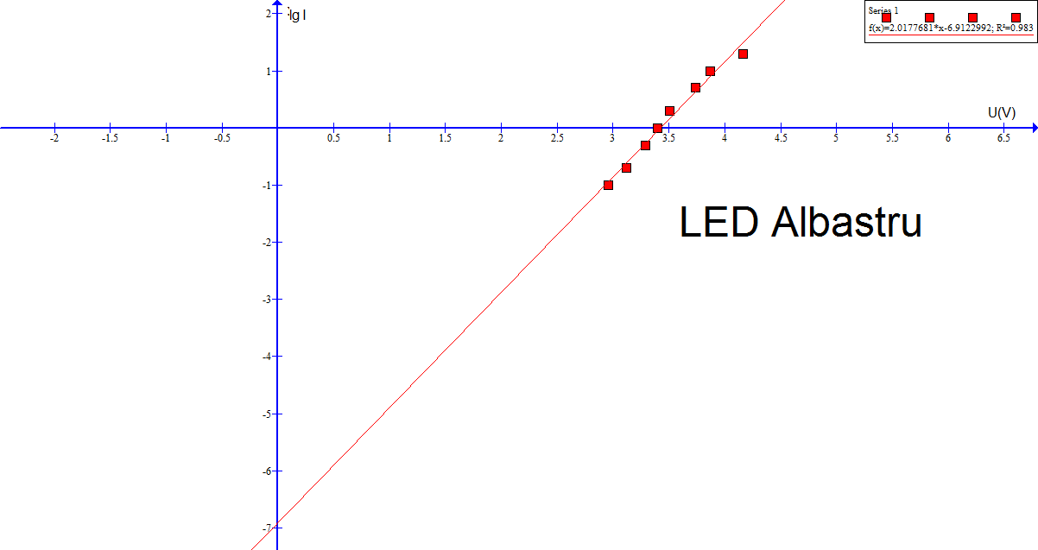

4. 1. Determinarea rezistentei dinamice pentru dioda de Siliciu:

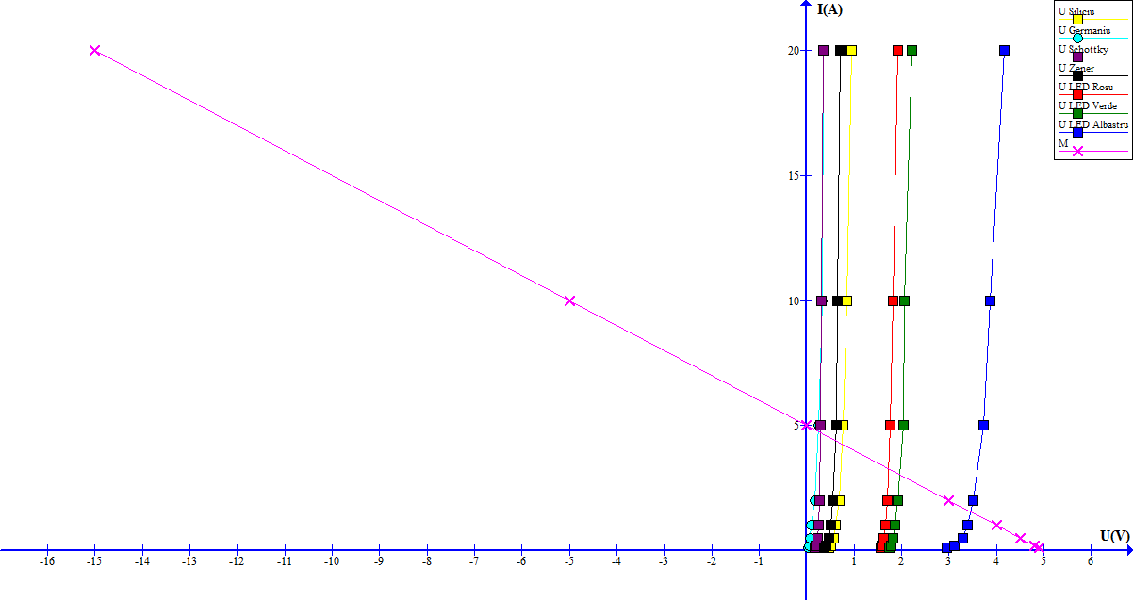

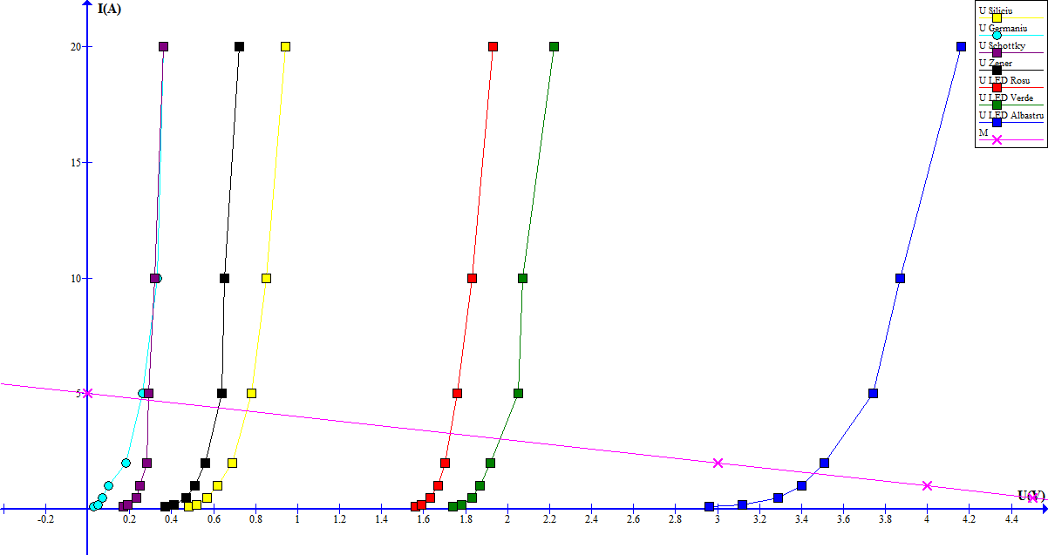

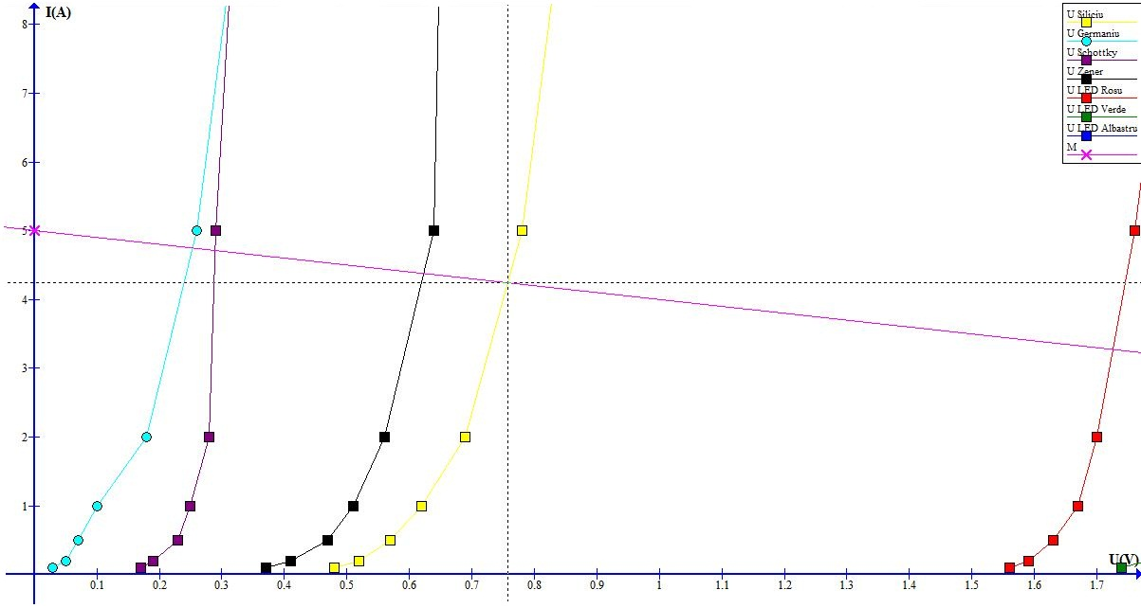

Pentru dioda 1, 1N4148:

* E = 5V
* R = 1kΩ
* ud = E - R * id
* M(Ud, Id)

Din grafic se observa Ud = 0.75V si Id = 4.25mA. => M(0.75, 4.24)

* 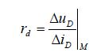 rd = 30 Ω

C:\Users\Radu\Desktop\Capture.JPG

* rd = 20.84Ω

4.2. Masurare marimi caracteristice Id si Ud:

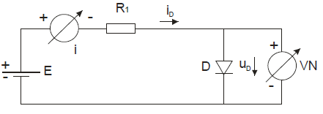

E = 5V

R1 = 1kΩ

Valori masurate:

|  |  |  |  |  |  |  |  |
| --- | --- | --- | --- | --- | --- | --- | --- |
|  | Siliciu | Germaniu | Schottky | Zener | R | G | B |
| Ud(V) | 0.69 | 0.14 | 0.27 | 0.59 | 1.75 | 1.93 | 3.45 |
| Id(mA) | 4.40 | 5.00 | 5.00 | 4.60 | 3.20 | 3.20 | 1.60 |

Valori calculate:

|  |  |  |  |  |  |  |  |
| --- | --- | --- | --- | --- | --- | --- | --- |
|  | Siliciu | Germaniu | Schottky | Zener | R | G | B |
| Ud(V) | 0.75 | 0.25 | 0.23 | 0.62 | 1.72 | 1.96 | 3.45 |
| Id(mA) | 4.24 | 4.74 | 4.70 | 4.37 | 3.20 | 3.03 | 1.54 |

5.1. Masurare curent invers prin diode de Germaniu:

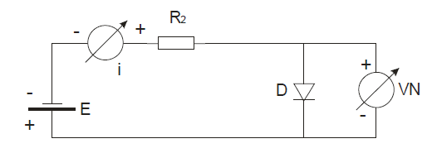

|  |  |  |  |  |
| --- | --- | --- | --- | --- |
| E(V) | 0 | 5 | 10 | 20 |
| U(V) | 0 | 4.60 | 9.55 | 19.45 |
| I(mA) | 0 | 0.06 | 0.06 | 0.08 |